- Story 1: Strengthening SI Mandate Validation at Source for the Canara Channel
- In response to increasing compliance expectations and the need to minimize downstream errors, the Operations and IT teams collaboratively identified a critical improvement opportunity in the Standing Instruction (SI) Mandate validation process.
- Traditionally, SI mandate checks were performed at later stages of processing, often leading to delays, rework, and potential risks in mandate authorization. Recognizing these inefficiencies, a proactive approach was proposed — to shift SI mandate validation to the source journey itself, leveraging advanced ICR/OCR (Intelligent/Optical Character Recognition)
- Enhance data accuracy
- Reduce operational turnaround time (TAT)
- Improve compliance adherence
- Minimize manual intervention and error rates
- The CR proposes integration of SI mandate validation rules directly within the ICR/OCR workflow, ensuring real-time verification at the point of document ingestion.
- To support this initiative, a comprehensive SOP outlining all validation checkpoints has been enclosed, ensuring clarity in execution and consistency across operations.

- Objective
  - To ensure accurate, complete, and compliant validation of SI Mandates at the source stage using ICR/OCR technology, thereby reducing errors and improving operational efficiency.

- Scope
  - This SOP applies to:
- 3.1.1. SI Mandate Forms received for processing may originate from digital or scanned channels. These forms can be either handwritten by the customer or pre-generated by the system, depending on the source and submission process.

- Process Overview
  - Document Upload / Capture
  - ICR/OCR Data Extraction
  - Automated Validation Check
  - Exception Handling

- Key Checkpoints for SI Mandate Validation
  - Requirement 1: Document Quality Check and Si mandate Validation
- Ensure the uploaded document is clear, legible, and complete and below fields should be mentioned in the SI Mandate Form, all fileds should match with the Proposal form as per other than Canara & Defence channel.
- Below are the validations that the system will perform as per the attached sheet.
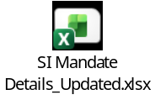
  - Requirement 2: SI Mandate Integration with Insta Issuance
    - The Insure system must integrate SI mandate functionality into the Insta Issuance process, in addition to the existing eNACH functionality.
    - After implementation, Insta Issuance should be triggered using either:
- SI mandate, or
- eNACH
- if the all details matched with as per above, then insta issuance will be Yes
    - In case image is not clear then the system shows the Error, please upload the Clear image, in case validation failed 3 times then Si Mandate form filling will be validation failed and user will upload the form & complete the journey and Unified will raise the PFR as per exiting process
    - In case user uploads image, which does not pertain to SI mandate form, then journey will not move ahead without upload of Actual SI Mandate form. Eg. Blank, documents other than SI mandate form etc and case movement will be as per existing.
    - No Fuzzy logic is required to match the account holder’s name, this should be 100% match

    - the Sales team should be provided with a maximum of 3 correction attempts for rectifying the required details. If the discrepancies are not resolved within these 3 attempts, the case should be automatically submitted on the third attempt with an "Insta-Issuance “N" flag for further processing and audit tracking.
    - Below are the Examples
Example 1: Name Mismatch
- Attempt 1: Customer name mismatch identified between Proposal Form and SI Form. Sales corrects the details.
- Attempt 2: Another mismatch remains in the father's name field. Sales updates the information again.
- Attempt 3: If any mismatch still exists, the application is automatically submitted with an Insta-Issuance Exception flag.
Example 2: Bank Name Mismatch
- Attempt 1: Bank name entered as "SBI" whereas the system expects "State Bank of India". Sales modifies the value.
- Attempt 2: Branch details are still incorrect. Sales updates the branch information.
- Attempt 3: If validation continues to fail, the case is submitted with an Insta-Issuance Exception flag.
Example 3: Application# Discrepancy
- Attempt 1: Application# does not match Pre Printed SI records. Sales updates the form Again .
- Attempt 2: Application# does not match Pre Printed SI records. Sales updates the form Again .Attempt 3: If any discrepancy still exists, the application is submitted with an Insta-Issuance Exception flag for review.
Example 4: Multiple Validation Failures
- Attempt 1: Name, DOB, and Bank Name mismatches identified. Sales updates all fields.
- Attempt 2: DOB is corrected, but Bank Name validation still fails.
- Attempt 3: System submits the case automatically with an Insta-Issuance Exception flag, even if one or more validations remain unresolved.

  - For a joint account holder, only the presence of the signature will be validated. If two signatures are present on the SI Form, the system will process the case and allow it to proceed further in the journey. No additional validation will be performed for the joint account holder details.
  - In the event of a failure during the first validation attempt, the user shall be provided with two opportunities to upload the correct SI document, with the validation error clearly communicated, Error Message Example: “ ICR/OCR failed due to Account Number Not readable.

    - Attaching the Field-Level Validation Error Messages to be displayed at UI
    - 

    - case sensitivity and spaces, system should remove itself from all fileds in SI Mandate form
    - Below are the examples only for reference.
Sr | Scenario | Proposal Form Value | SI Form Value | Expected Result | Remarks
1 | Case Sensitivity | RAVI SHARMA | ravi sharma | Pass | System should ignore upper/lower case differences during validation.
2 | Case Sensitivity | Ravi Sharma | RAVI SHARMA | Pass | Name comparison should be case-insensitive.
3 | Case Sensitivity | RAVI Sharma | ravi SHARMA | Pass | Mixed case values should be treated as identical.
4 | Case Sensitivity | RaVi ShArMa | ravi sharma | Pass | Validation should ignore character casing.
5 | Extra Spaces Between Words | RAVI SHARMA | RAVI SHARMA | Pass | Multiple spaces should be normalized before comparison.
6 | Extra Spaces Between Words | RAVI SHARMA | RAVI SHARMA | Pass | Extra spaces in SI Form should not impact validation.
7 | Leading and Trailing Spaces | RAVI SHARMA | ** RAVI SHARMA ** | Pass | Leading and trailing spaces should be ignored.
8 | Mixed Case and Spaces | RAVI SHARMA | ravi sharma | Pass | Validation should ignore both case and multiple spaces.
9 | Multiple Spaces and Mixed Case | RAVI Sharma | rAvI ShArMa | Pass | Case and extra spaces should not cause mismatch.
10 | Tab/Additional White Space | RAVI SHARMA | RAVI SHARMA | Pass | Any additional white spaces between words should be trimmed/normalized.
11 | Single Space vs Multiple Spaces | RAVI SHARMA | RAVI SHARMA | Pass | Space normalization should be applied before validation.
12 | Case and Trailing Space | RAVI SHARMA | **ravi sharma ** | Pass | Trailing spaces and case differences should be ignored.

    - Example – Multiple Validation Failures
Example: If the Account Number is missing, Bank Name does not match the Proposal details, and the Account Holder Signature is missing in the SI form, the system should display all three applicable errors along with Si form uploaded attempts
- Account Number is missing in the uploaded SI Form. Please ensure the Account Number is clearly mentioned and upload the correct SI Form.
- The SI Amount in the SI Form does not match the premium amount provided in the proposal details. Please verify and update the SI from.
- The Account Holder Name mentioned in the SI Form does not match the Proposer Name provided in the proposal details. Please verify and correct the information in the SI form.

    - Attaching wireframe for the reference
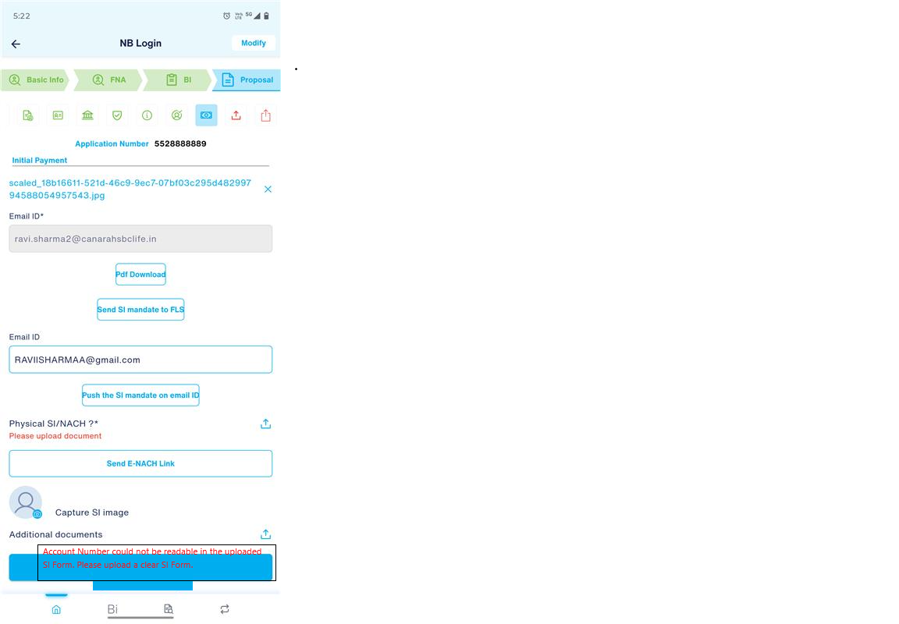

  - If the SI remains discrepant after the third attempt, the application submission shall be permitted; however, Insta Issuance will be set to 'N', and a SI PFR will be generated for subsequent processing as per existing process
  - Below are the bank names supported by the system. During SI Mandate validation, the bank name may be captured either by the FLS or extracted from the uploaded SI Mandate Form.

  - The system should validate the bank name by considering both the full bank name and its commonly used abbreviation/short form. Therefore, if the SI Mandate Form contains either the abbreviated bank name (e.g., SBI) or the complete bank name (e.g., State Bank of India), the validation should be treated as successful and should not fail solely due to the use of an abbreviation or any case sensitivity.

  - Accordingly, the master list of bank names should include all supported banks along with their recognized abbreviations to ensure accurate matching and avoid validation failures resulting from different naming conventions.
  - list of banks for reference. If any new bank is added in the future, the system should be capable of handling the same exception automatically without requiring any code changes.
  - 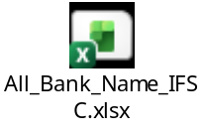
Sr | Abbreviation | Full Form
1 | SBI | State Bank of India
2 | RBI | Reserve Bank of India
3 | PNB | Punjab National Bank
4 | BOB | Bank of Baroda
5 | BOI | Bank of India
6 | BOM | Bank of Maharashtra
7 | CBI | Central Bank of India
8 | UBI | Union Bank of India
9 | UCO | United Commercial Bank (UCO Bank)
10 | IOB | Indian Overseas Bank
11 | IB | Indian Bank
12 | PSB | Punjab & Sind Bank
13 | CB | Canara Bank
14 | HDFC | Housing Development Finance Corporation Bank
15 | ICICI | Industrial Credit and Investment Corporation of India Bank
16 | IDBI | Industrial Development Bank of India
17 | IDFC | Infrastructure Development Finance Company First Bank
18 | AXIS | Axis Bank
19 | KMB | Kotak Mahindra Bank
20 | YES | Yes Bank
21 | IIB | IndusInd Bank
22 | SIB | South Indian Bank
23 | KVB | Karur Vysya Bank
24 | CUB | City Union Bank
25 | CSB | CSB Bank (Catholic Syrian Bank)
26 | DCB | Development Credit Bank (DCB Bank)
27 | RBL | Ratnakar Bank Limited (RBL Bank)
28 | LVB | Lakshmi Vilas Bank
29 | HSBC | Hongkong and Shanghai Banking Corporation
30 | SCB | Standard Chartered Bank
31 | DBS | Development Bank of Singapore
32 | EXIM | Export-Import Bank of India
33 | SIDBI | Small Industries Development Bank of India
34 | NABARD | National Bank for Agriculture and Rural Development
35 | NHB | National Housing Bank
36 | KAGB | Karnataka Gramin Bank
37 | KVGB | Karnataka Vikas Grameena Bank
38 | APGB | Andhra Pragathi Grameena Bank
39 | SGB | Saptagiri Grameena Bank
40 | TGGB | Telangana Grameena Bank
41 | AGVB | Assam Gramin Vikash Bank
42 | BGGB | Bangiya Gramin Vikash Bank
43 | UGB | Uttarbanga Kshetriya Gramin Bank
44 | BRKGB | Baroda Rajasthan Kshetriya Gramin Bank
45 | MGB | Madhya Pradesh Gramin Bank
46 | JKGB | Jammu & Kashmir Grameen Bank
47 | PGB | Punjab Gramin Bank
48 | HPGB | Himachal Pradesh Gramin Bank
49 | Utkal GB | Utkal Grameen Bank
50 | CGB | Chhattisgarh Rajya Gramin Bank
51 | BGVB | Baroda Gujarat Gramin Bank
52 | SGGSGB | Sarva Haryana Gramin Bank
53 | TGB | Tripura Gramin Bank
54 | MBGB | Manipur Rural Bank
55 | NGB | Nagaland Rural Bank
56 | MzRB | Mizoram Rural Bank
57 | ARGB | Arunachal Pradesh Rural Bank
58 | JGrB | Jharkhand Rajya Gramin Bank
59 | BUPGB | Baroda UP Bank
60 | AUPGB | Aryavart Bank
61 | UGB | Uttarakhand Gramin Bank
62 | BSVB | Bihar Gramin Bank
63 | DBGB | Dakshin Bihar Gramin Bank
64 | PBGB | Paschim Banga Gramin Bank
65 | OGB | Odisha Gramya Bank

  - Exception Handling
- Any failed validation to be automatically flagged
- Route exception cases to manual review queue as per existing process.
  - Audit Trail should be maintained in the system
- Maintain logs of(Ensure traceability for compliance review while any failure)
- Extracted data from the Document
- Validation results as per field wise

- Upload attempts count
- Failed fields result (Error Message to be captured)
- Insta-Issuance flag for SI(N/Y(Case wise))

  - SI Document & SOP attached
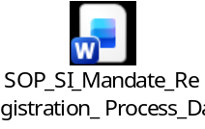
  - Validation Flow
1. User uploads the SI Form.
2. System verifies that the uploaded document is a valid and readable SI Form.
3. System extracts the required fields from the uploaded SI Form.
4. For Account Number, Bank Name, Amount, Application Number and Account Holder Name, system compares the extracted value against the corresponding value in the Proposal Form.
5. For Account Holder Signature and Canara Bank Seal, system verifies that the required element is present and identifiable.
6. If a field is missing, unreadable, invalid or mismatched, the system displays the corresponding error message.
7. If multiple validations fail, the system should display all applicable errors rather than only the first error.
8. If all validations pass, the system displays the validation-success message and allows the process to continue.

  - Need to be removed current below validation
    - Validation to be removed for "Amt in words", not need to verify this.
- Test case
  - Verify system allows upload of valid SI Mandate form.
  - Verify system rejects blank document upload.
  - Verify system rejects non-SI document upload.
  - Verify system displays error when uploaded image is unreadable.
  - Verify OCR extracts Account Number successfully from SI form.
  - Verify error is displayed when Account Number is missing.
  - Verify error is displayed when Account Number is unreadable.
  - Verify Account Number matches exactly with Proposal Form.
  - Verify error is displayed when Account Number does not match Proposal Form.
  - Verify Bank Name is extracted correctly from SI form.
  - Verify error is displayed when Bank Name is missing.
  - Verify error is displayed when Bank Name is unreadable.
  - Verify Bank Name matches exactly with Proposal Form.
  - Verify error is displayed when Bank Name mismatches Proposal Form.
  - Verify Amount in Figure is extracted correctly.
  - Verify error is displayed when Amount is missing.
  - Verify error is displayed when Amount is unreadable.
  - Verify Amount matches Proposal Form.
  - Verify error is displayed for invalid amount format.
  - Verify Application Number is extracted correctly.
  - Verify error is displayed when Application Number is missing.
  - Verify Application Number matches Proposal Form.
  - Verify Account Holder Name matches proposer name exactly.
  - Verify error is displayed when Account Holder Name is missing.
  - Verify Account Holder Signature is present.
  - Verify error is displayed when signature is missing.
  - Verify Canara Bank Seal is present.
  - Verify error is displayed when Canara Bank Seal is missing.
  - Verify all validation error messages are displayed simultaneously for multiple failures.
  - Verify successful validation message is displayed when all fields match.
  - Verify user gets maximum 3 upload attempts for correction.
  - Verify SI PFR is raised after validation failure beyond allowed attempts.
  - Verify Insta Issuance is triggered upon successful SI validation.
  - Verify case sensitivity is ignored during name validation.
  - Verify leading, trailing and multiple spaces are ignored during validation.
  - Verify audit logs are maintained for extraction, validation and user actions.
  - Verify Penny Drop flag is passed from iNSURE to Unified.

